**WEB PROGRAMMING MINI PROJECT – REPORT**

**TITLE: MARVEL STORE**

Name: Palachuri Mohan Vamsi

Reg No: RA1711003011119

**INTRODUCTION**

**MARVEL STORE** is a web based Online Shopping application, which sells the Marvel Merchandise. The first page would be a Sign-up page where a customer can either create an Account or Log in with the existing account. Customers can also skip the sign up to have a look at the products. After successfully signing up, customer is now able to see all the products available. There are four sections of the Merchandise namely Clothing, Action Figures, Back Packs and Mobile Covers.

In Every Section there is a hover feature available which enlarges the image size of the particular product where the cursor is placed.

**Clothing page** consists of poster printed T-shirts of Marvel Cinematic Universe for both men and women.

**Action Figures** page consists of the action figures of the super heroes and their weapons in the Marvel Cinematic Universe.

**Back Packs** page consists of poster printed backpacks of Marvel Cinematic Universe.

**Mobile Covers** page consists of Mobile cases/covers which are printed with the poster of Marvel Cinematic Universe and it also has some glowing cases in which some part of the Mobile case glows with light in which the light turns off and turns on repetitively.

In each section, there is a Add to cart button under every product. This button helps customers to allocate every product page they need at one place where they are able to see the total purchase amount. Customer can add or remove the products from the cart according to their wish. After finalizing the list of products for the purchase the customer can choose the payment method in his convenience.

**SOFTWARE USED**



**HTML**: **Hypertext Markup Language** (HTML) is the standard markup language for documents designed to be displayed in a web browser. It can be assisted by technologies such as Cascading Style Sheets (CSS) and scripting languages such as JavaScript.HTML can embed programs written in a scripting language such as JavaScript, which affects the behavior and content of web pages. Inclusion of CSS defines the look and layout of content. The World Wide Web Consortium (W3C), former maintainer of the HTML and current maintainer of the CSS standards, has encouraged the use of CSS over explicit presentational HTML since 1997.



**PHP: Hypertext Preprocessor** is a general-purpose scripting language especially suited to web development. It was originally created by Danish-Canadian programmer Rasmus Lerdorf in 1994. The PHP reference implementation is now produced by The PHP Group. PHP originally stood for Personal Home Page, but it now stands for the recursive initialism PHP: Hypertext Preprocessor.

PHP code is usually processed on a web server by a PHP interpreter implemented as a module, a daemon or as a Common Gateway Interface (CGI) executable. On a web server, the result of the interpreted and executed PHP code – which may be any type of data, such as generated HTML or binary image data – would form the whole or part of an HTTP response. Various web template systems, web content management systems, and web frameworks exist which can be employed to orchestrate or facilitate the generation of that response. Additionally, PHP can be used for many programming tasks outside of the web context, such as standalone graphical applications and robotic drone control. Arbitrary PHP code can also be interpreted and executed via command-line interface (CLI).



**JavaScript** often abbreviated as JS, is a programming language that conforms to the ECMAScript specification. JavaScript is high-level, often just-in-time compiled, and multi-paradigm. It has curly-bracket syntax, dynamic typing, prototype-based object-orientation, and first-class functions.

Alongside HTML and CSS, JavaScript is one of the core technologies of the World Wide Web. JavaScript enables interactive web pages and is an essential part of web applications. The vast majority of websites use it for client-side page behavior, and all major web browsers have a dedicated JavaScript engine to execute it.

As a multi-paradigm language, JavaScript supports event-driven, functional, and imperative programming styles. It has application programming interfaces (APIs) for working with text, dates, regular expressions, standard data structures, and the Document Object Model (DOM). However, the language itself does not include any input/output (I/O), such as networking, storage, or graphics facilities, as the host environment (usually a web browser) provides those APIs.

JavaScript engines were originally used only in web browsers, but they are now embedded in some servers, usually via Node.js. They are also embedded in a variety of applications created with frameworks such as Electron and Cordova.

Although there are similarities between JavaScript and Java, including language name, syntax, and respective standard libraries, the two languages are distinct and differ greatly in design.

**FLOW CHART**

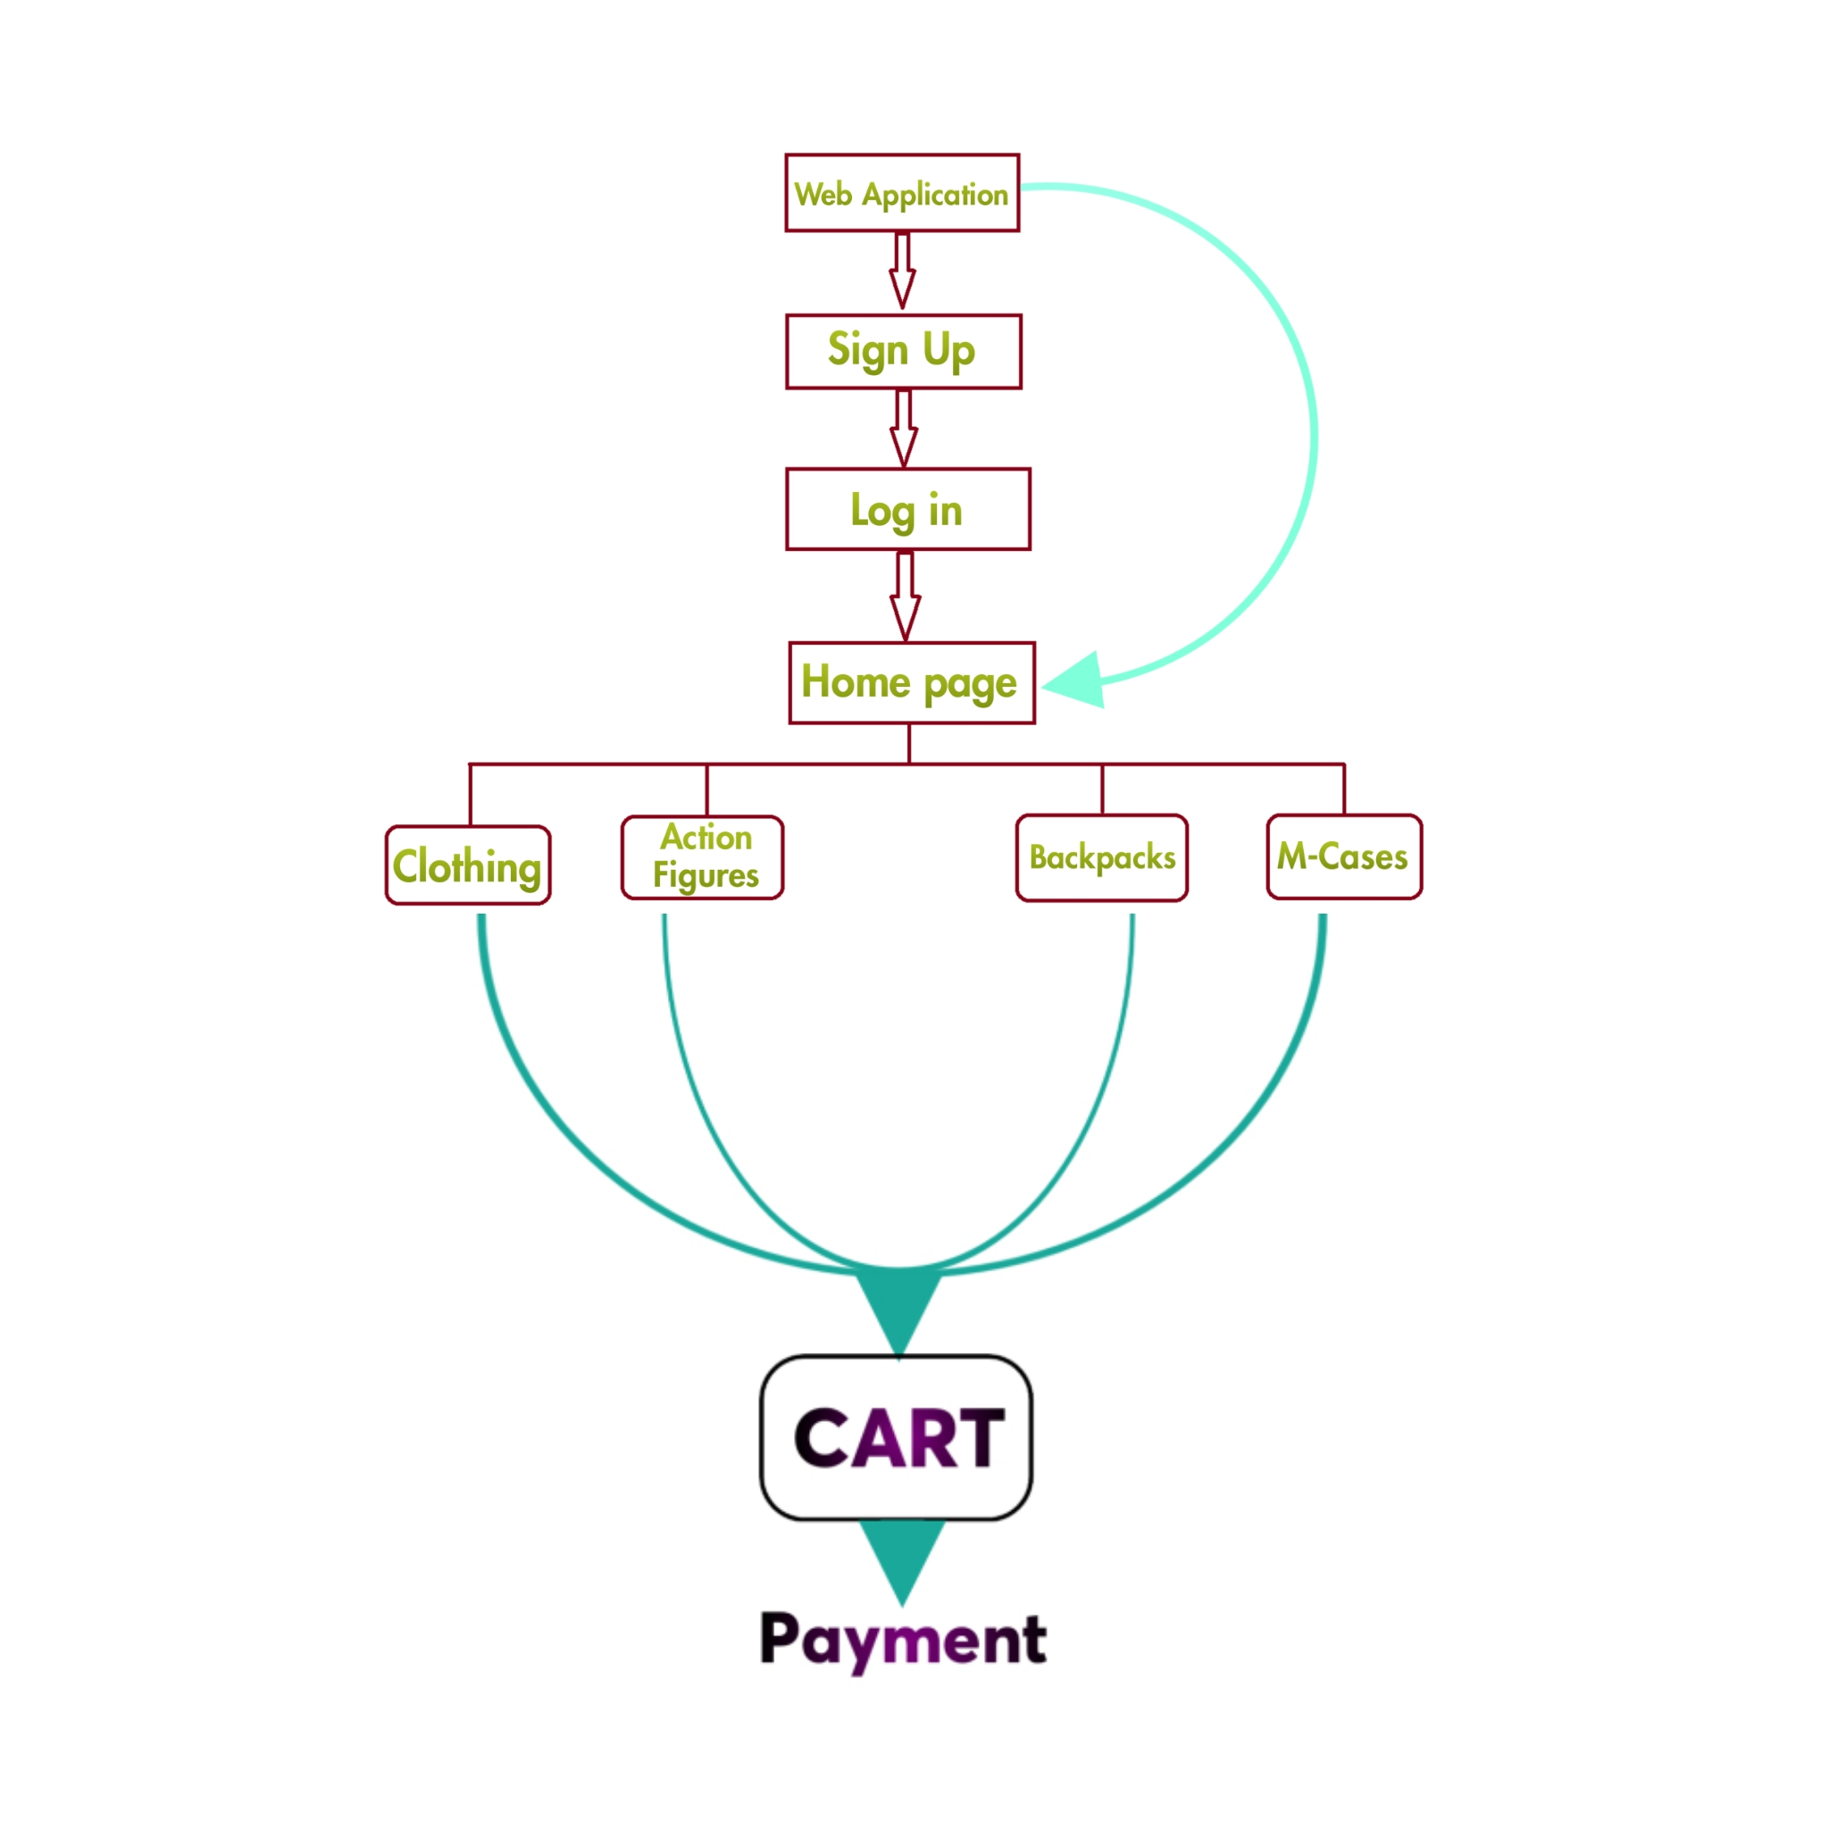

**IMPLEMENTATION**

CODE:

**Signup.html**

<html>

<head>

<title>Log In to MARVEL</title>

<link rel="stylesheet" href="sign up.css">

</head>

<div class="spf">

<img src="user.png">

<h1>Sign Up</h1>

<script src="emailvalid.js"></script>

<form method="POST" action="sign up.php.txt"></form>

<form name="myform" method="post" action="file:///C:/xampp/htdocs/website/log%20in.html" onsubmit="return validateemail();">

<input type="User Name" class="inpbox" placeholder="User Name" required>

<input type="email" class="inpbox" placeholder="Email" required>

<input type="password" class="inpbox" placeholder="Password" required>

<input type="submit" value="Sign Up"> <br>

<hr>

<p>Already Have an Account ?<a href="log in.html"> Log In now</a></p>

</form>

</div>

</body>

</html>

**Signup.php**

<?php

$servername ="localhost";

$username = "root";

$password = "";

$dbname = "marvels";

$conn = new mysqli($servername, $username, $password, $dbname);

if($conn->connect_error){

die("connection failed");

}

$email = $_POST["email"];

$password = $_POST["password"];

$salt = "codeflix";

$password_encrypted = sha1($password.$salt);

$sql = mysqli_query($conn, "SELECT count(*) as total from signup WHERE email = '".$email."' and

password = '".$password_encrypted."'");

$row = mysqli_fetch_array($sql);

if($row["total"] > 0){

?>

<script>

alert('Login successful');

</script>

<?php

}

else{

?>

<script>

alert('Login failed');

</script>

<?php

}

?>

**Login.html**

<html>

<head>

<title>Log In to MARVEL</title>

<link rel="stylesheet" href="login.css">

</head>

<div class="sif">

<img src="user.png">

<br>

<h3>You've Successfully Signed Up</h3>

<h1>Log In</h1>

<script src="emailvalid.js"></script>

<form name="myform" method="post" action="file:///C:/xampp/htdocs/website/index.html" onsubmit="return validateemail();">

<input type="email" class="inb" placeholder="Email" required>

<input type="password" class="inb" placeholder="Password" required>

<input type="submit" value="Log In"> <br>

<hr>

<p>Not a user ?<a href="signup.html"> Sign Up now</a></p>

</form>

</div>

</body>

</html>

**Emailvalid.js**

function validateemail()

{

var x=document.myform.email.value;

var atposition=x.indexOf("@");

var dotposition=x.lastIndexOf(".");

if (atposition<1 || dotposition<atposition+2 || dotposition+2>=x.length){

alert("Please enter a valid e-mail address \n atpostion:"+atposition+"\n dotposition:"+dotposition);

return false;

}

}

**Index.html**

<html>

<head>

<title>MARVEL webstore</title>

<link href="style.css" rel="stylesheet" type="text/css">

<link rel="stylesheet" href="https://cdnjs.cloudflare.com/ajax/libs/font-awesome/4.7.0/css/font-awesome.min.css">

</head>

<body>

<header>

<div class="top">

<ul class="nav-menu">

<li class="hb"> <a href="cloth.html">Clothing</a></li>

<li class="hb"> <a href="toys.html">Toys</a></li>

<li class="hb"> <a href="bags.html">Back Packs</a></li>

<li class="hb"> <a href="m-covers.html">Mobile Covers</a></li>

</ul>

</div>

<div class="tag">

<h3>What are you LOOKING for ?</h3>

</div>

<div class="til">

<img src="logo1.png" width=50% class="center">

</div>

<div class="wgp">

</div>

<div class="footer">

<p><u>Contact Us</u></p>

<br>

<p>Our Social Media Profiles</p>

<a href="#" class="fa fa-facebook"></a>

<a href="#" class="fa fa-instagram"></a>

<a href="#" class="fa fa-google"></a>

<a href="#" class="fa fa-twitter"></a>

</div>

</header>

</body>

</html>

**Style.css**

*

{

margin:0;

padding:0;

}

header {

background-image: linear-gradient(rgba(0,0,0,0.5), rgba(0,0,0,0.5)),url("marvel.jpg");

height:100vh;

background-size:cover;

background-position:center;

}

.nav-menu{

float: right;

list-style:none;

margin-top: 325px;

margin-right: 385px;

}

.nav-menu li{

display: inline-block;

}

.nav-menu li a{

position: relative;

color: mediumspringgreen;

text-decoration:none;

text-shadow:0px 1px 2px black;

padding: 5px 20px;

font-family:"Verdana","sans-serif";

font-size:20px;

left: 30%;

}

.nav-menu li a:hover {

border:1px solid gray;

background-color: rgb(0, 0, 0);

}

.tag{

position: absolute;

width: 1200px;

margin-left: 0;

margin-right:0 ;

}

h3{

color:white;

font-size:25px;

font-family:"Lucida Sans Unicode", "Lucida Grande", sans-serif;

margin-left: 500px;

text-shadow:2px 1px 1px black;

margin-top: 275px;

}

.til{

position: absolute;

margin-left: 460px;

margin-top: 25px;

}

h1{

color:rgb(22, 177, 224);

font-size:38px;

font-family: "Trebuchet MS", Helvetica, sans-serif;

margin-left:345px;

margin-top:50px;

text-shadow:2px 1px 1px black;

text-decoration:underline;

}

.wgp{

position: absolute;

width: 1200px;

margin-left: 0;

margin-right:0 ;

}

h2{

color:rgb(111, 164, 180);

font-size:18px;

font-family:"Lucida Sans Unicode", "Lucida Grande", sans-serif;

margin-left:464px;

margin-top:100px;

text-shadow:2px 1px 1px black;

text-decoration:none;

}

.footer {

position: fixed;

left: 0;

bottom: 0;

height: 25%;

width: 100%;

background-color: rgba(0,0,0,0.5);

color: greenyellow;

text-align: center;

font-size: 135%;

font-family: Verdana, Geneva, Tahoma, sans-serif;

}

.fa {

padding: 6px;

font-size: 30px;

width: 50px;

text-align: center;

text-decoration: none;

margin: 5px 2px;

}

.fa:hover {

opacity: 0.7;

}

.fa-facebook {

background: #3B5998;

color: white;

size: 10cm;

}

.fa-twitter {

background: #55ACEE;

color: white;

}

.fa-google {

background: #dd4b39;

color: white;

}

.fa-linkedin {

background: #007bb5;

color: white;

}

.fa-youtube {

background: #bb0000;

color: white;

}

.fa-instagram {

background: #125688;

color: white;

}

**Clothing.html**

<html>

<head>

<title>Clothing</title>

<link href="cl.css" rel="stylesheet" type="text/css">

<link rel="stylesheet" href="https://use.fontawesome.com/releases/v5.4.1/css/all.css">

</head>

<body>

<div class="search">

<input class="inp" type="text" name="box" placeholder="search for products here">

<a class="sbt" href="#">

<i class="fas fa-search"></i>

</a>

</div>

<br><br>

<table border="0" width="100%">

<tr>

<th class="zoom"><img src="a1.jpeg" width="65%"></th>

<th class="zoom"><img src="a2.jpeg" width="65%"></th>

<th class="zoom"><img src="a3.jpeg" width="65%"></th>

<th class="zoom"><img src="a4.jpeg" width="60%"></th>

</tr>

<tr style="text-align:center">

<th class="pr"><pre>599/-</pre><a href="#"><button type="button" class="rate">Add To Cart</button></a></th>

<th class="pr"><pre>599/-</pre><a href="#"><button type="button" class="rate">Add To Cart</button></a></th>

<th class="pr"><pre>599/-</pre><a href="#"><button type="button" class="rate">Add To Cart</button></a></th>

<th class="pr"><pre>599/-</pre><a href="#"><button type="button" class="rate">Add To Cart</button></a></th>

</tr>

<br><br>

<tr>

<th class="zoom"><img src="a5.jpeg" width="65%"></th>

<th class="zoom"><img src="a6.jpeg" width="65%"></th>

<th class="zoom"><img src="a7.jpeg" width="65%"></th>

<th class="zoom"><img src="a8.jpeg" width="65%"></th>

</tr>

<tr style="text-align:center">

<th class="pr"><pre>599/-</pre><a href="#"><button type="button" class="rate">Add To Cart</button></a></th>

<th class="pr"><pre>599/-</pre><a href="#"><button type="button" class="rate">Add To Cart</button></a></th>

<th class="pr"><pre>599/-</pre><a href="#"><button type="button" class="rate">Add To Cart</button></a></th>

<th class="pr"><pre>599/-</pre><a href="#"><button type="button" class="rate">Add To Cart</button></a></th>

</tr>

</table>

</body>

</html>

**Actionfig.html**

<html>

<head>

<title>Action Figures</title>

<link href="cl.css" rel="stylesheet" type="text/css">

<link rel="stylesheet" href="https://use.fontawesome.com/releases/v5.4.1/css/all.css">

</head>

<body>

<div class="search">

<input class="inp" type="text" name="box" placeholder="search for products here">

<a class="sbt" href="#">

<i class="fas fa-search"></i>

</a>

</div>

<br><br>

<table border="0" width="100%">

<tr>

<th class="zoom"><img src="t1.jpeg" width="65%"></th>

<th class="zoom"><img src="t2.jpeg" width="65%"></th>

<th class="zoom"><img src="t3.jpeg" width="65%"></th>

<th class="zoom"><img src="t4.jpeg" width="60%"></th>

</tr>

<tr style="text-align:center">

<th class="pr"><pre>599/-</pre><a href="#"><button type="button" class="rate">Add To Cart</button></a></th>

<th class="pr"><pre>599/-</pre><a href="#"><button type="button" class="rate">Add To Cart</button></a></th>

<th class="pr"><pre>599/-</pre><a href="#"><button type="button" class="rate">Add To Cart</button></a></th>

<th class="pr"><pre>599/-</pre><a href="#"><button type="button" class="rate">Add To Cart</button></a></th>

</tr>

<br><br>

<tr>

<th class="zoom"><img src="t5.jpeg" width="65%"></th>

<th class="zoom"><img src="t6.jpeg" width="65%"></th>

<th class="zoom"><img src="t7.jpeg" width="65%"></th>

<th class="zoom"><img src="t8.jpeg" width="65%"></th>

</tr>

<tr style="text-align:center">

<th class="pr"><pre>599/-</pre><a href="#"><button type="button" class="rate">Add To Cart</button></a></th>

<th class="pr"><pre>599/-</pre><a href="#"><button type="button" class="rate">Add To Cart</button></a></th>

<th class="pr"><pre>599/-</pre><a href="#"><button type="button" class="rate">Add To Cart</button></a></th>

<th class="pr"><pre>599/-</pre><a href="#"><button type="button" class="rate">Add To Cart</button></a></th>

</tr>

</table>

</body>

</html>

**Bags.html**

<html>

<head>

<title>Back Packs</title>

<link href="cl.css" rel="stylesheet" type="text/css">

<link rel="stylesheet" href="https://use.fontawesome.com/releases/v5.4.1/css/all.css">

</head>

<body>

<div class="search">

<input class="inp" type="text" name="box" placeholder="search for products here">

<a class="sbt" href="#">

<i class="fas fa-search"></i>

</a>

</div>

<br><br>

<table border="0" width="100%">

<tr>

<th class="zoom"><img src="b1.jpeg" width="65%"></th>

<th class="zoom"><img src="b2.jpeg" width="65%"></th>

<th class="zoom"><img src="b3.jpeg" width="65%"></th>

<th class="zoom"><img src="b4.jpeg" width="60%"></th>

</tr>

<tr style="text-align:center">

<th class="pr"><pre>599/-</pre><a href="#"><button type="button" class="rate">Add To Cart</button></a></th>

<th class="pr"><pre>599/-</pre><a href="#"><button type="button" class="rate">Add To Cart</button></a></th>

<th class="pr"><pre>599/-</pre><a href="#"><button type="button" class="rate">Add To Cart</button></a></th>

<th class="pr"><pre>599/-</pre><a href="#"><button type="button" class="rate">Add To Cart</button></a></th>

</tr>

<br><br>

<tr>

<th class="zoom"><img src="b5.jpeg" width="65%"></th>

<th class="zoom"><img src="b6.jpeg" width="65%"></th>

<th class="zoom"><img src="b7.jpeg" width="65%"></th>

<th class="zoom"><img src="b8.jpeg" width="65%"></th>

</tr>

<tr style="text-align:center">

<th class="pr"><pre>599/-</pre><a href="#"><button type="button" class="rate">Add To Cart</button></a></th>

<th class="pr"><pre>599/-</pre><a href="#"><button type="button" class="rate">Add To Cart</button></a></th>

<th class="pr"><pre>599/-</pre><a href="#"><button type="button" class="rate">Add To Cart</button></a></th>

<th class="pr"><pre>599/-</pre><a href="#"><button type="button" class="rate">Add To Cart</button></a></th>

</tr>

</table>

</body>

</html>

**M-covers.html**

<html>

<head>

<title>Mobile Covers</title>

<link href="cl.css" rel="stylesheet" type="text/css">

<link rel="stylesheet" href="https://use.fontawesome.com/releases/v5.4.1/css/all.css">

</head>

<body>

<div class="search">

<input class="inp" type="text" name="box" placeholder="search for products here">

<a class="sbt" href="#">

<i class="fas fa-search"></i>

</a>

</div>

<br><br>

<table border="0" width="100%">

<tr>

<th class="zoom"><img src="p1.jpeg" width="65%"></th>

<th class="zoom"><img src="p2.jpeg" width="65%"></th>

<th class="zoom"><img src="p3.jpeg" width="65%"></th>

<th class="zoom"><img src="p4.jpeg" width="60%"></th>

</tr>

<tr style="text-align:center">

<th class="pr"><pre>599/-</pre><a href="#"><button type="button" class="rate">Add To Cart</button></a></th>

<th class="pr"><pre>599/-</pre><a href="#"><button type="button" class="rate">Add To Cart</button></a></th>

<th class="pr"><pre>599/-</pre><a href="#"><button type="button" class="rate">Add To Cart</button></a></th>

<th class="pr"><pre>599/-</pre><a href="#"><button type="button" class="rate">Add To Cart</button></a></th>

</tr>

<br><br>

<tr>

<th class="zoom"><img src="p5.jpeg" width="65%"></th>

<th class="zoom"><img src="p6.jpeg" width="65%"></th>

<th class="zoom"><img src="p7.jpeg" width="65%"></th>

<th class="zoom"><img src="p8.jpeg" width="65%"></th>

</tr>

<tr style="text-align:center">

<th class="pr"><pre>599/-</pre><a href="#"><button type="button" class="rate">Add To Cart</button></a></th>

<th class="pr"><pre>599/-</pre><a href="#"><button type="button" class="rate">Add To Cart</button></a></th>

<th class="pr"><pre>599/-</pre><a href="#"><button type="button" class="rate">Add To Cart</button></a></th>

<th class="pr"><pre>599/-</pre><a href="#"><button type="button" class="rate">Add To Cart</button></a></th>

</tr>

</table>

</body>

</html>

**SCREENSHOTS**

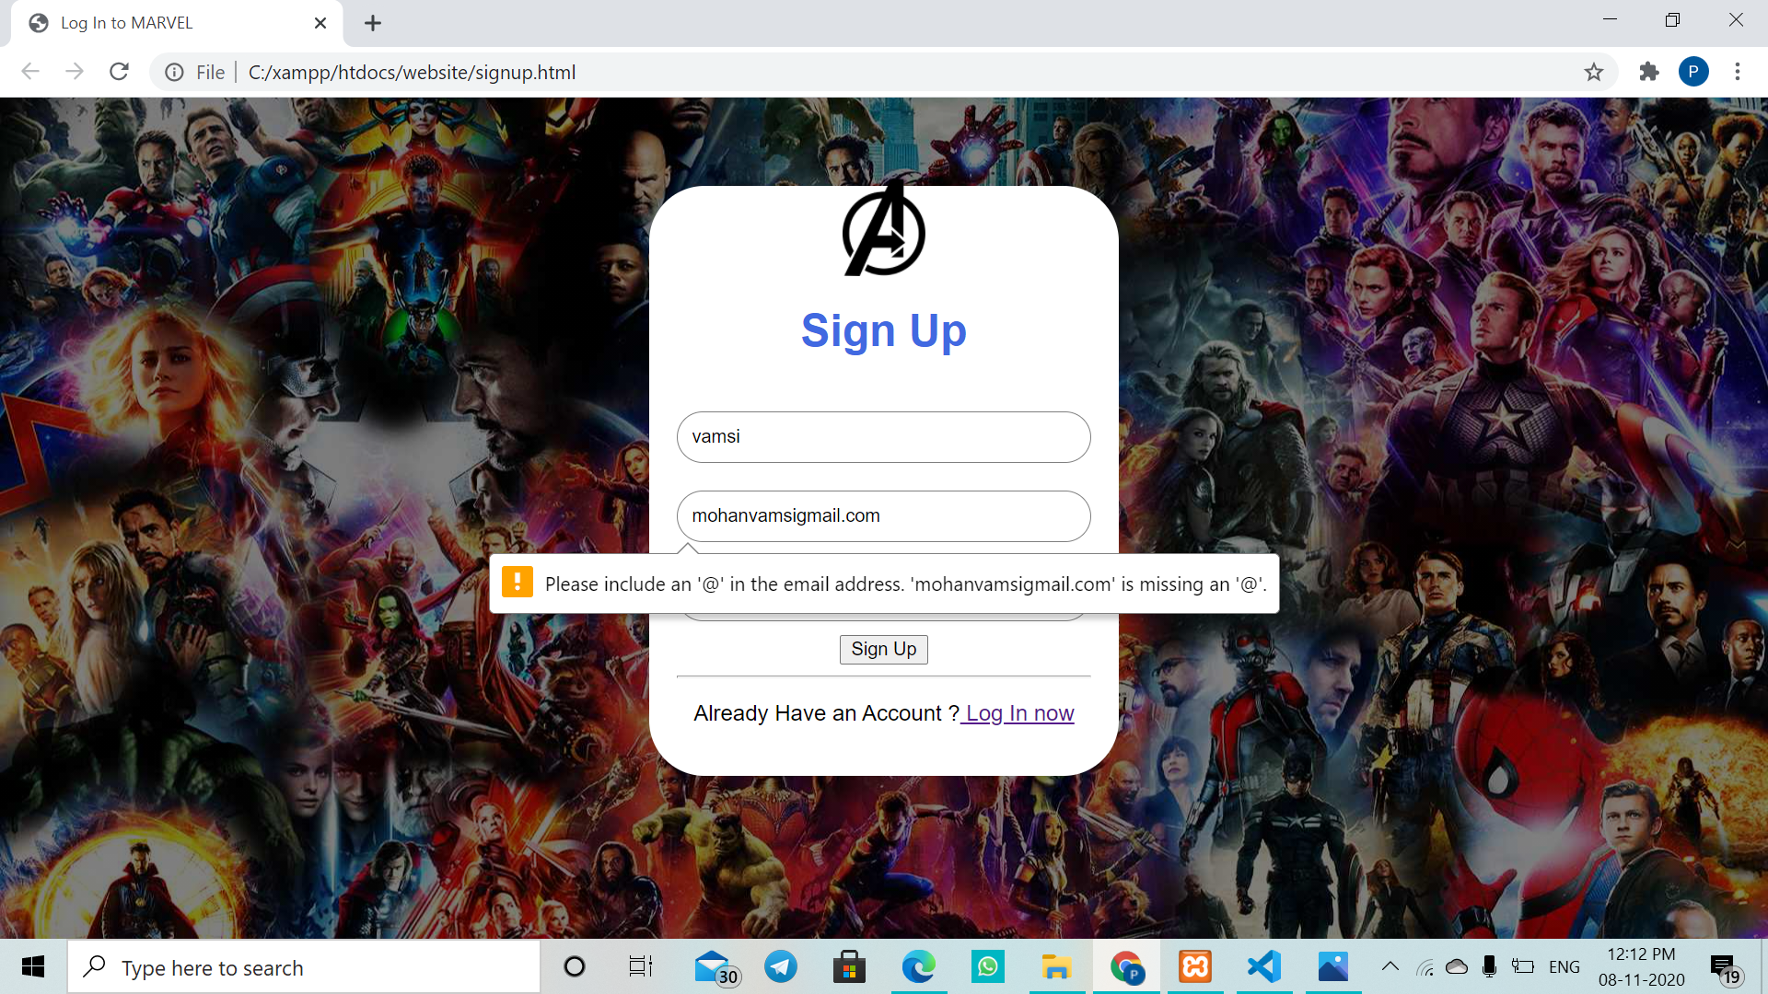

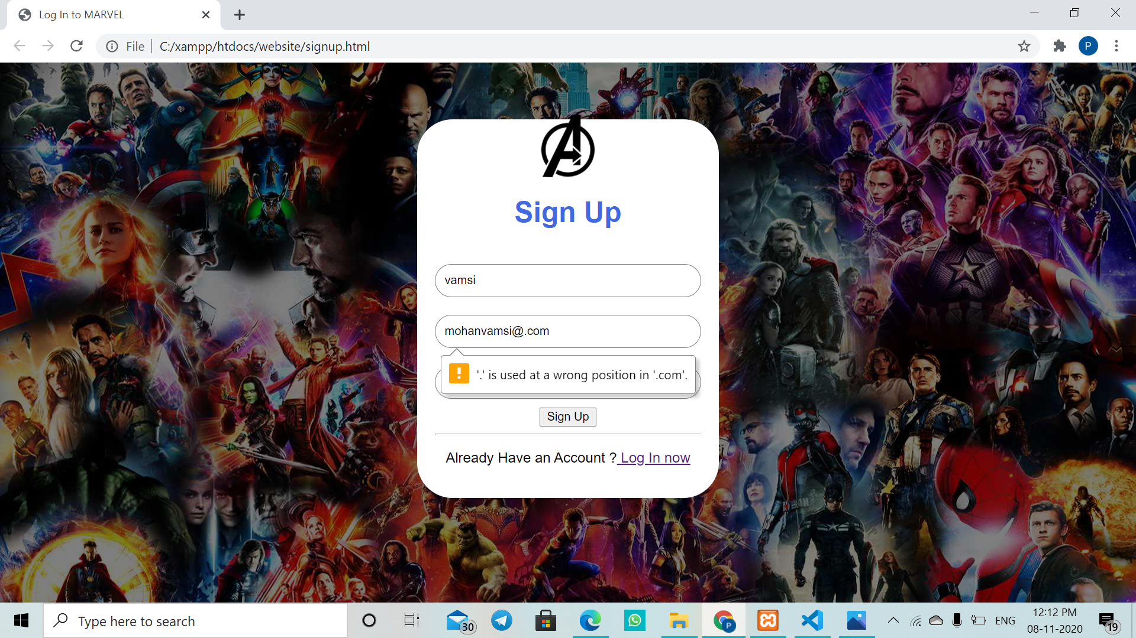

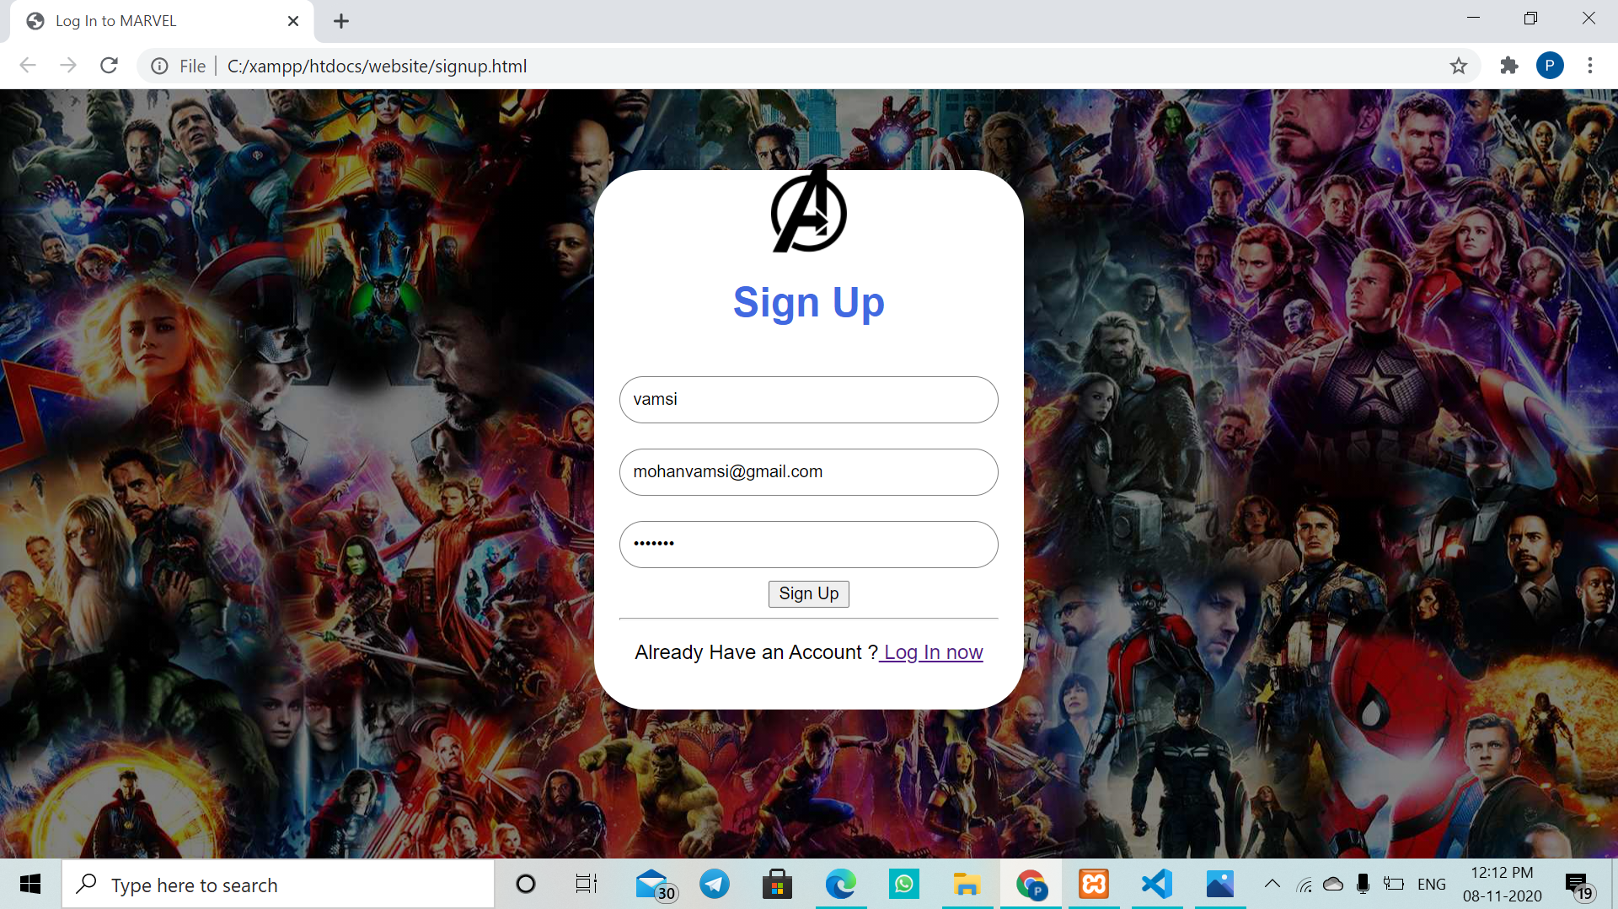

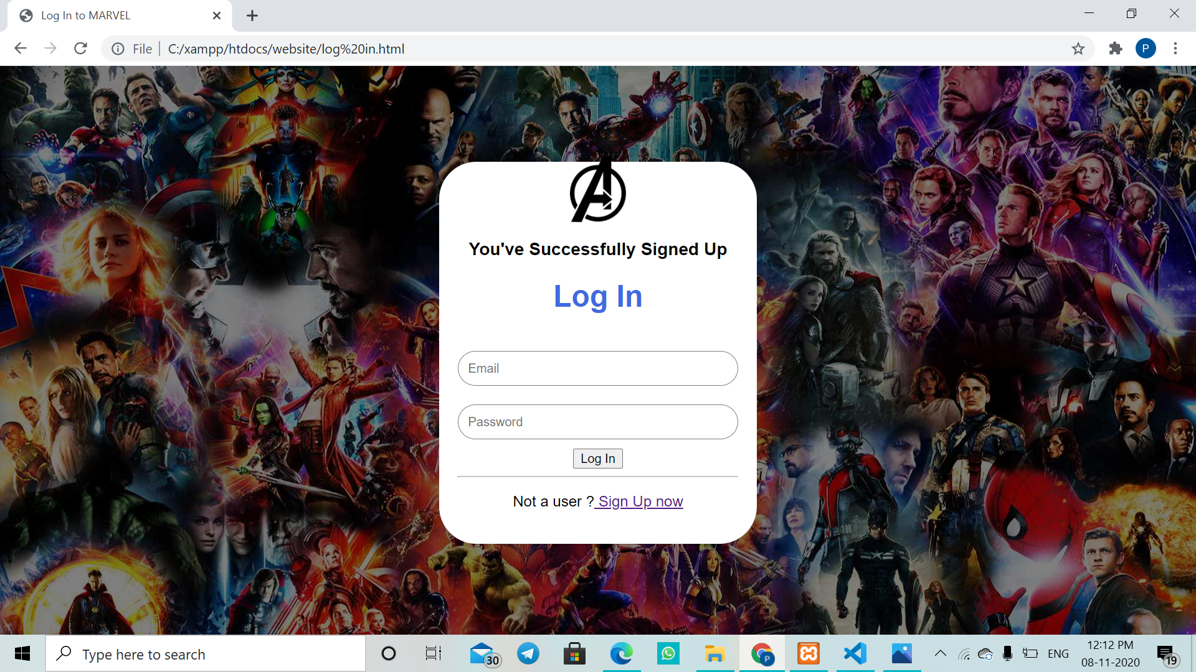

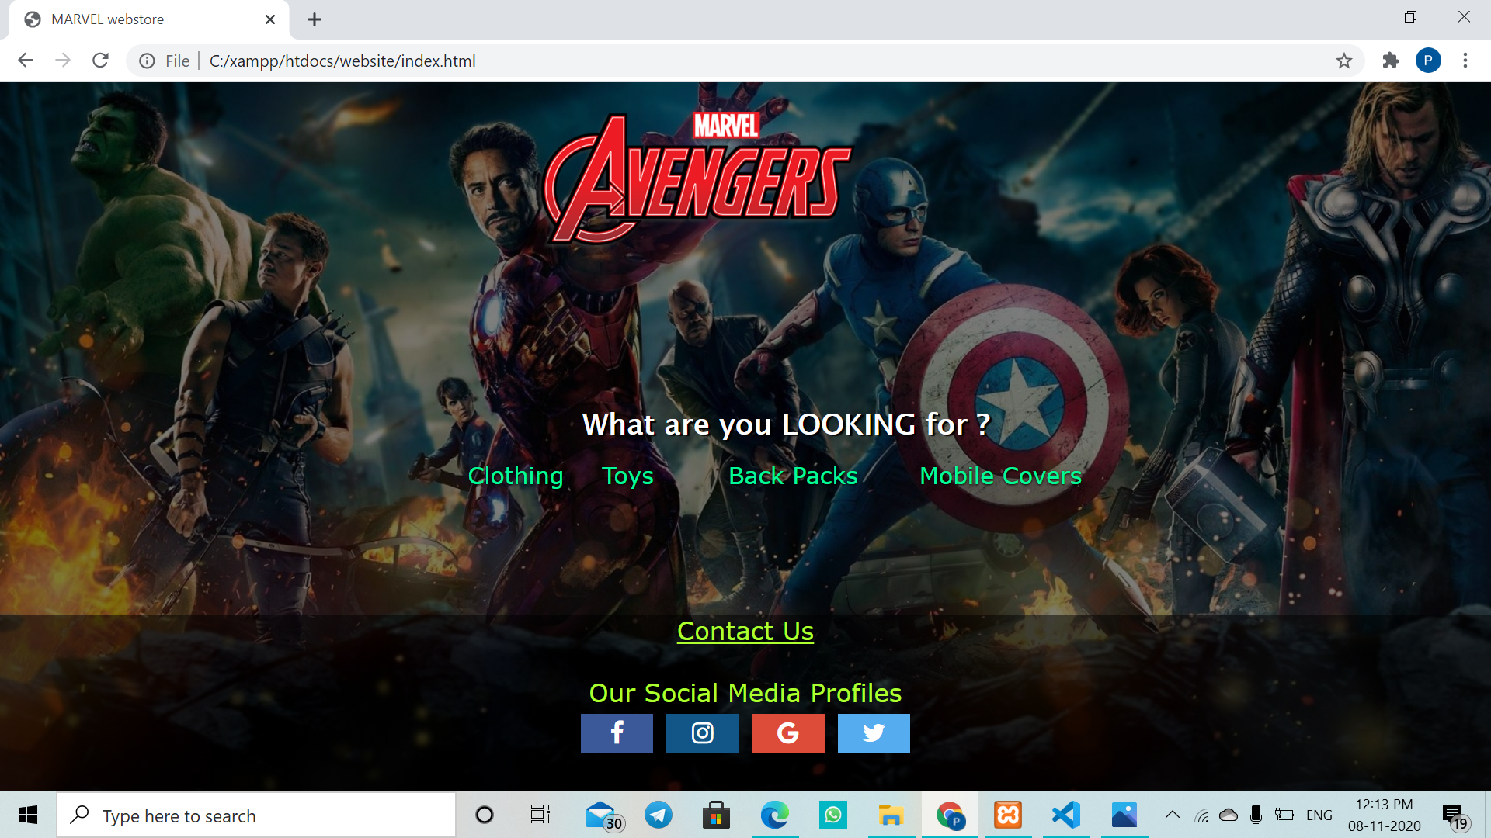

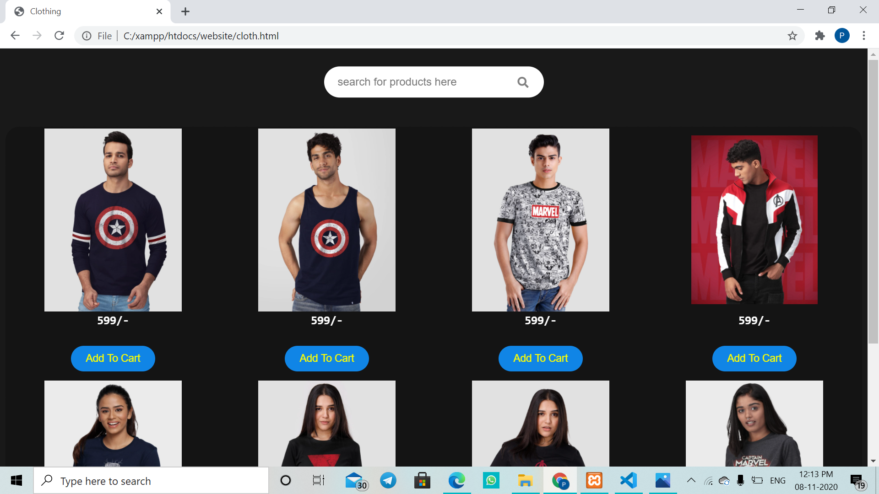

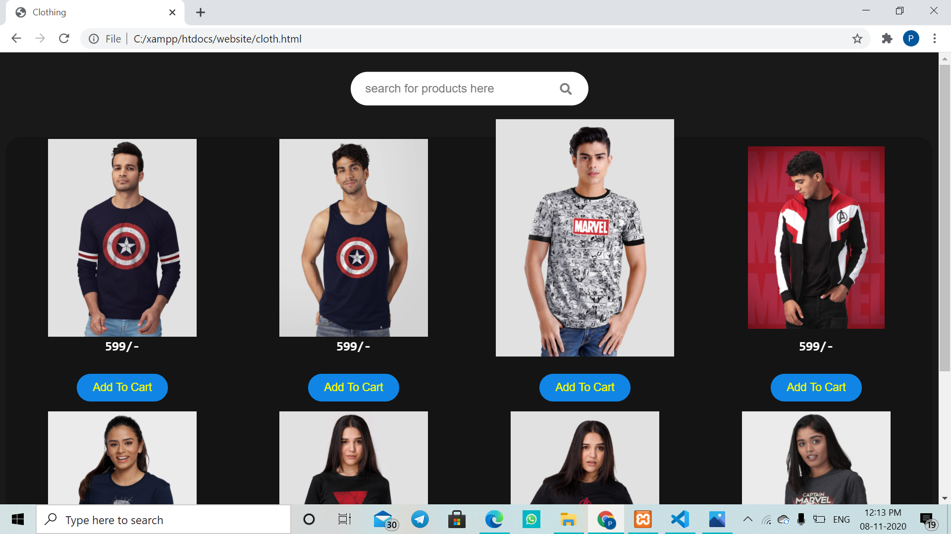

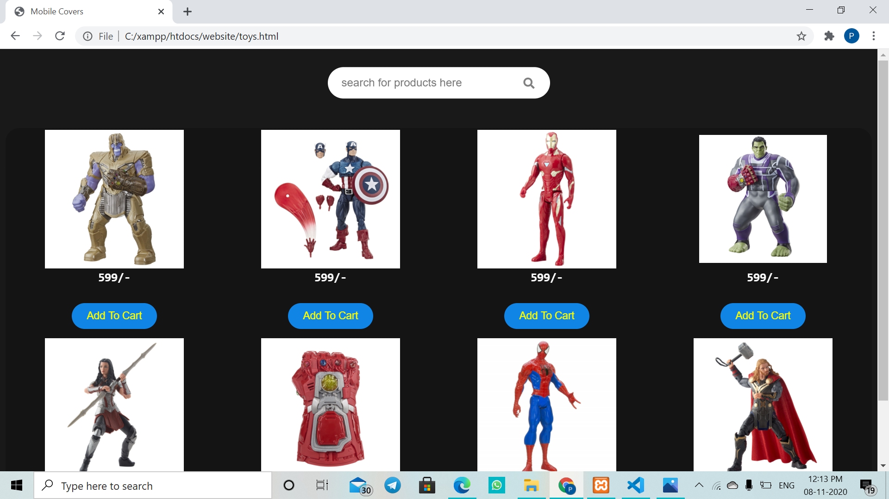

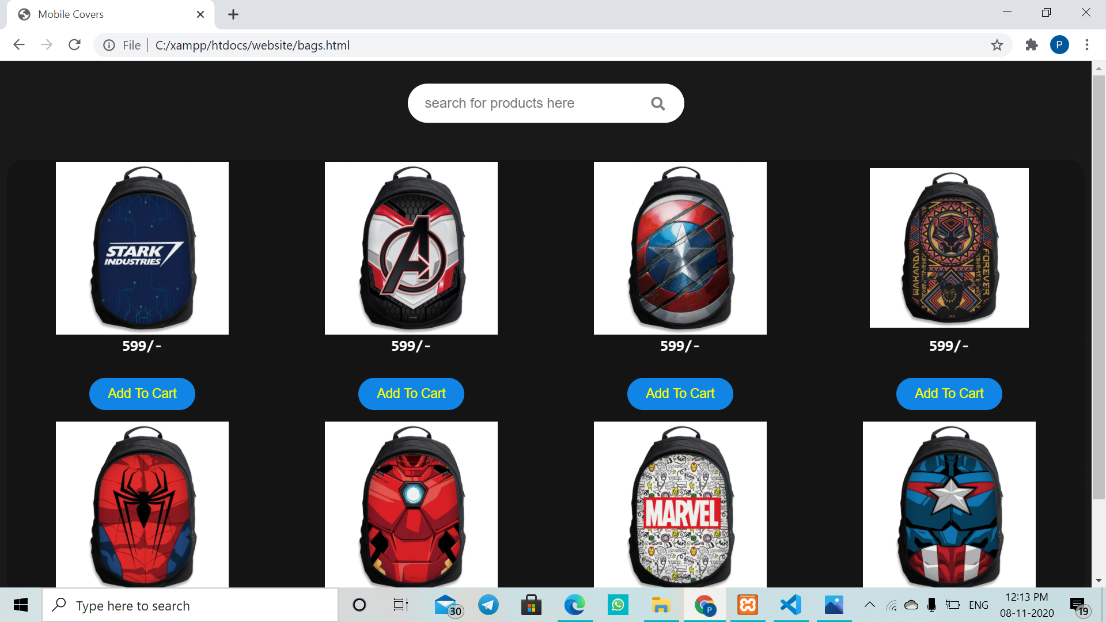

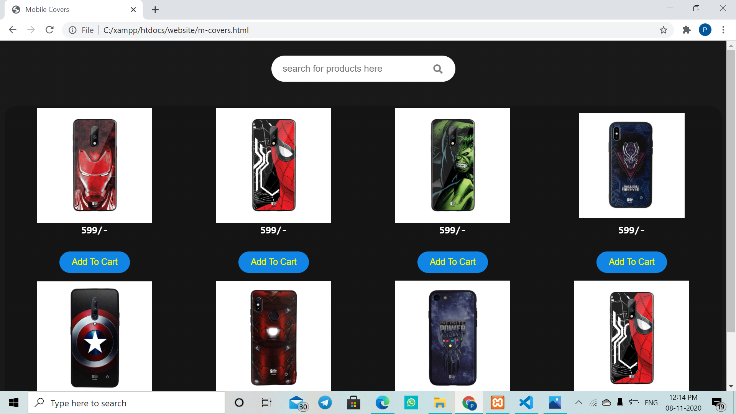

**CONCLUSION**

The Marvel Store is an E-Commerce website where customers can buy Marvel Merchandise such as T-shirts, Action figures, Back packs and Mobile cases.

**REFERENCES**

<https://www.javatpoint.com/>

<https://www.w3schools.com/>